Internship Opportunities within the Disability Resource Office at RU
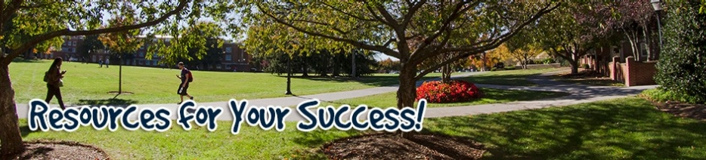
The Disability Resource Office at Radford University is committed to providing equal educational opportunities for all qualified students. Through the Disability Resource Office, Radford University provides reasonable academic accommodations for students with documented disabilities. The DRO also supports disability accommodation requests from parents and visitors.
All DRO staff members are Disability Services Specialists serving students living with disabilities. Staff members have additional expertise in the areas of LD/ADD/ADHD, Deafness and Deaf Culture, and Adaptive Technologies. The DRO serves diagnoses including (but not limited to):
- Learning Disabilities
- Hearing loss
- Psychiatric
- Medical
- Sight loss
- Speech difficulties
- Mobility challenges
- Neurological
- ADD/ADHD
- Autism
- Temporary disabilities: As a result of an illness or accident, a student may be eligible for temporary services from the DRO.
Students with career aspirations in many health, education, and human services fields, seeking an internship with the DRO, should contact the Director, Angela DeVore-Greene.
Angela DeVore-Greene, Director
Lower Level Tyler Hall
amdevore@radford.edu
540.831.6350

