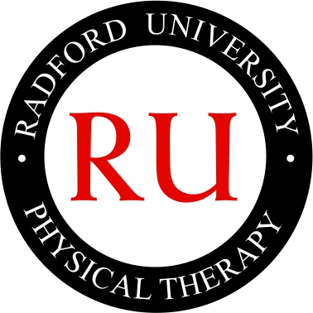

Community Service Reflection Paper

Please submit an electronic copy of the following form to your Faculty advisor within two weeks of completion of the activity, or by the last day of final examinations (if the activity occurred within two weeks of final exams). Retain a copy for your own records.

Student Name
Student Year in Program
Date of Service Activity
Name of Service Activity
Number of Hours
Faculty Advisor  (Please Initial) | ☐ Approved  ☐ Not Approved  Comments:

Please answer the following questions:

1) Provide a brief summary of the Activity that was completed. (100 words or less)

The Radford University Department of Physical Therapy Mission Statement

Our mission is to develop culturally sensitive autonomous practitioners of physical therapy. These practitioners will serve the physical therapy needs of rural communities, the Commonwealth of Virginia, and the region. The development of autonomous practitioners will be facilitated through an engaging and challenging intellectual and psychomotor teaching/ learning environment that is student focused. Research is considered a vital corollary to the teaching/ learning process leading to lifelong learning and the creation of new knowledge to meet current and future healthcare needs of society.

2) Define the community that you served and how it relates to our program’s Mission Statement. (300 words or less)

3) Would you recommend this activity to another student? Why? (100 words or less)

Signature:_______________________________________ Date:____________

