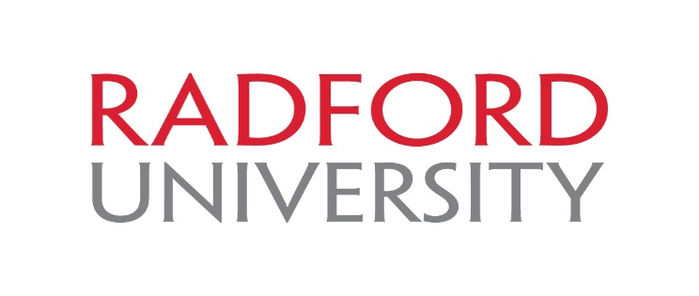

Coordinator of Graduate Recruitment

The Coordinator of Graduate Recruitment at Radford University is primarily responsible for expanding the graduate applicant pool, particularly in targeted programs having both capacity and interest in growth. This position leads the development and implementation of a comprehensive strategy to recruit, enroll, and retain a talented and diverse graduate student population. The Coordinator of Graduate Recruitment is responsible for strategically implementing best practices in graduate recruitment as appropriate for target markets in individual programs. Additional responsibilities include organizing and sustaining collaborations with graduate program coordinators; researching graduate fair opportunities and representing the Graduate College at selected fairs; arranging and offering campus tours, designing and managing correspondence and making phone calls to prospective students; managing the design and deployment of marketing materials and advertisements (e.g., radio, newspaper, social media, emerging digital formats); overseeing the graduate recruitment budget; manage the design and implementation of vendor contracts; liaising with University Relations to ensure compliance with branding campaign and to promote Graduate College activities and programs; oversee preparation and distribution of the Graduate College's monthly newsletter; maintain the Graduate College's website, and supervise recruitment personnel including graduate assistants. This is a full-time, 12-month, administrative/professional faculty position with a July 1, 2016 start date.

About Radford University: Radford University is a comprehensive public university of nearly 10,000 students that has received national recognition for many of its undergraduate and graduate academic programs, as well as its sustainability initiatives. Well known for its strong faculty/student bonds, innovative use of technology in the learning environment and vibrant student life on a beautiful 204-acre American classical campus, Radford University offers students many opportunities to get involved and succeed in and out of the classroom. The university offers 67 degree programs in 38 disciplines and two certificates at the undergraduate level; 22 master's programs in 17 disciplines and three doctoral programs at the graduate level; 10 post-baccalaureate certificates and one post-master's certificate.

Qualifications: Advanced degree in business/education or related field and demonstrated experience in marketing or equivalent training, education, or experience. Self-starter with demonstrated evidence of ability to work independently, with limited supervision. Excellent communication skills. Experience working in a team environment. Preference for experience with higher education marketing.

Application Instructions: Apply online at http://jobs.radford.edu. Complete a faculty application and attach a cover letter, resume/cv, and a list of three professional references. Only online applications will be accepted. Review of applications will begin on March 14, 2016.

Radford University is an EO/AA employer committed to diversity. All new hires to Radford University will be subject to E-Verify beginning June 1, 2011. E-Verify is administered by the U.S. Department of Homeland Security, USCIS-Verification Division and the Social Security Administration and allows participating employers to electronically verify employment eligibility.

This contractor and subcontractor shall abide by the requirements of 41 CFR 60-300.5(a). This regulation prohibits discrimination against qualified protected veterans, and requires affirmative action by covered prime contractors and subcontractors to employ and advance in employment qualified protected veterans.

