CLINICAL EDUCATION HANDBOOK

2024-2025

Table of Contents
OVERVIEW 3
CURRICULUM 4
CLINICAL EDUCATION SITE AND DEPARTMENT REQUIREMENTS 5
PREPARATION FOR CLINICAL EDUCATION EXPERIENCES 5
CLINICAL SITE SUGGESTIONS & NEW CONTRACTS 6
CLINICAL EDUCATION SITE SELECTION & ASSIGNMENT 7
SEQUENCE OF CLINICAL EXPERIENCES 10
ACADEMIC CALENDAR: TIMING OF CLINICAL EXPERIENCES 11
UNIVERSITY ROLES, RESPONSIBILITIES & RIGHTS 11
DPT CLINICAL EXPERIENCE ABSENCE POLICY 15
DRESS CODE 16
HOUSING & MEALS 16
TRAVEL & TRANSPORTATION POLICY 16
DIRECTOR OF CLINICAL EDUCATION, CLINICAL INSTRUCTOR ROLES, RESPONSIBILITIES & RIGHTS 17
DCE ASSESSMENT 17
CLINICAL FACULTY ROLES AND RESPONSIBILITIES 18
CI ASSESSMENT 18
CLINICAL FACULTY RIGHTS AND PRIVILEGES 18
POLICIES 19
CLINICAL REMEDIATION/DISMISSAL POLICY & PROCEDURES 20
COMMUNICATIONS TECHNOLOGY POLICY 21
GRADE DETERMINATION 23
APPENDICES 25

This handbook is a tool utilized to effectively communicate with Clinical Education Faculty (Site Coordinators [SCCEs]; Clinical Instructors [CIs]), and Radford University Doctor of Physical Therapy (DPT) students about the Clinical Education Program within the DPT program.

It includes:
- A list of the responsibilities of the Director of Clinical Education (DCE), clinical education faculty, and students.
- A description of the rights and privileges of clinical education faculty.
In the event of an emergency, please contact the Director of Clinical Education (DCE) directly: Renée Huth, PT, DPT, PhD, DCE
Advanced Credentialed CI; APTA Fellow of Higher Education Leadership
Radford University, Doctor of Physical Therapy Program 101 Elm Ave SE, Room 829, Roanoke, VA 24013
Office Phone (540) 831-1892; Fax (540) 224-6660
rhuth@radford.edu

Other helpful contacts/information:
Department Website address: http://www.radford.edu/content/wchs/home/pt.html

Statement of Candidacy/Accreditation
The Doctor of Physical Therapy Program at Radford University is accredited by the Commission on Accreditation in Physical Therapy Education (CAPTE), 3030 Potomac Ave., Suite 100, Alexandria, Virginia 22305-3085; telephone: 703-706-3245; website: http://www.capteonline.org. If needing to contact the program/institution directly, please call 540-831-1880 or email DPT@radford.edu

OVERVIEW
The Department of Physical Therapy aspires to prepare responsive and engaged professionals who lead by example by providing best-practice care. Our program vision parallels the APTA’s 2030 Vision, “Transforming society by optimizing movement to improve the human experience.” Physical therapists are recognized by consumers and other health care professionals as practitioners of choice to whom consumers have direct access for the diagnosis of, interventions for, and prevention of impairments, functional limitations, and disabilities related to movement, function, and health. Offering the Doctor of Physical Therapy (DPT) degree is one example of Radford University’s commitment to educating highly competent practitioners to serve the needs of the Commonwealth of Virginia and the nation. This department strives to develop leading practitioners who will improve access and quality of care for aging and underserved populations.
The DPT program features strong partnerships with local and national businesses, hospitals, and public schools to offer a variety of experiential learning experiences. This diversity will prepare our students to provide quality physical therapy care throughout the lifespan of the population. Radford University's interdepartmental associations also provide a multitude of positive on-campus learning opportunities.
CURRICULUM
For information about the DPT curriculum, and the program’s vision, mission, values, principles, and program outcomes: https://www.radford.edu/content/grad/home/academics/graduate-programs/pt.html.
The Clinical Education supports the program’s Vision, Mission, Values, and Principles by providing opportunities that:
- Develop autonomous practitioners who engage and integrate scientific inquiry into clinical practice to optimize the human experience and meet diverse community needs.
- Engage students in intellectually and culturally diverse environments that support the development of autonomous, life-long learner physical therapy practitioners who give back to their communities.
- Integrate foundational and clinical sciences in current evidence-based practice that supports the life-long learner process.
The Clinical Education Program supports the Program’s Graduate Performance Outcomes (GPOs)/goals by providing student opportunities before graduation to:
- Practice as autonomous, entry-level practitioners.
- Practice in an ethical and culturally competent manner.
- Communicate effectively with the patient, their families, and members of the interprofessional healthcare team.
- Integrate evidence-based practice throughout the continuum of care.
- Participate in scholarly activities.
- Engage in life-long learning to advance the profession of physical therapy.

Short descriptions of the three-course clinical education course series:
- Year 1: AHPT 830: The Clinical Experience I is the first in a series of courses designed to provide physical therapy students with an opportunity to apply the first year of didactic learning through real-world experience. This is the first of a series of three clinical experiences. It requires full-time hours (typically 40 hours) per week over 12 weeks. The student is expected to demonstrate Beginner-level skills or higher across the APTA Clinical Performance Instrument [CPI] by the end of this clinical semester. *
- Year 2: AHPT 870: The Clinical Experience II is the second in a series of courses designed to provide physical therapy students with an opportunity to apply the first and second years of didactic learning and knowledge, skills, and abilities gained within the first clinical experience through real-world experience. Students are expected to focus on personally identified areas in need of improvement based on previous progress as noted on previous CPIs clinical education coursework. It requires full-time hours (typically 40 hours) per week over 12 weeks. The student is expected to demonstrate intermediate-level skills or higher across the APTA Clinical Performance Instrument [CPI] by the end of this clinical semester. *
- Year 3: AHPT 890: The Clinical Experience III is the third in a series of courses designed to provide physical therapy students with an opportunity to apply prior years of didactic learning,. knowledge, skills, and abilities gained within prior experiences through real-world experience. Students are expected to focus on personally identified areas in need of improvement based on previous progress as noted on previous CPIs clinical education coursework. It requires full-time hours (typically 40 hours) per week over 12 weeks. The student is expected to demonstrate Entry-level skills or higher across the APTA Clinical Performance Instrument [CPI] by the end of this clinical semester. *

*Should course expectations not be achieved, a review conducted by the instructor of record (DCE), in collaboration with the program chair, will ensue, with required SMART plan development and/or program dismissal.

Significant concerns related to consistent demonstration of lacking core values affecting performance warrant immediate attention and more expansive documentation, and (at minimum) a telephone call to the DCE, e.g., among them attendance issues, unpreparedness, and lack of accountability.

Possible outcomes from difficulty in performance with a red-flag item may include remediation via a SMART plan, additional clinical experience time, dismissal from the clinical experience, and/or program dismissal

PRACTICE ACT & LICENSURE
Physical Therapy clinical faculty (clinical instructors [CIs}) are required to practice under the regulations of their state’s Practice Act and licensure and should be available on the US state or territory’s website. For example, Virginia’s license look-up website is https://dhp.virginiainteractive.org/Lookup/Index.

CLINICAL EDUCATION SITE AND DEPARTMENT REQUIREMENTS
The DPT clinical education curricular requirements include at minimum that full-time clinical placements meet the following criteria.
- Diverse settings, which means that all clinical placements must vary by setting type, and as possible by location and company.
- Consist of patient care that includes, but is not limited to, neurological and orthopedic diagnoses.
- Include care across the continuum of care which means that students have access to treat various levels of patient acuity.
- Include access to patients across the lifespan which means access to patients who are below 18 years of age (pediatrics) and above 18 years of age (adults; geriatrics).

The program is required by the Commission on Accreditation in Physical Therapy Education to provide students access to settings representative of common practice. Clinical experiences may be directly assigned to ensure that minimum clinical education requirements are met.

PREPARATION FOR CLINICAL EDUCATION EXPERIENCES
- During the initial clinical education orientation (first fall semester), students will be provided instructions about the clinical placement process.
- During each preclinical semester, students will be reminded to maintain DPT programmatic requirements and complete any additional site-specific requirements. Students who do not complete site-specific requirements within the site-assigned deadlines may be denied placement by the site. There are no guarantees for reassignment when sites cancel due to student requirements not being met.
- The preclinical semester also includes at minimum one meeting with the DCE to review the DPT program and site requirements. Each site and agreement describe varying student preclinical requirements; this is the purpose of meeting with the DCE.
The DCE in coordination with the Radford University Procurement and Contracts Office establishes clinical agreements with clinics that provide physical therapy services.

*All clinical experiences are 12 weeks full-time to meet the minimum required 36-week total full-time clinical experience requirements under the direct supervision of licensed Physical Therapists.

*Local/specific placements cannot be guaranteed, and students should expect to budget accordingly for alternate housing and travel outside of the local area during all clinical education experiences.

*It is recommended that each student budget approximately $4000 extra for clinical semesters to cover items such as rent, gas, food, etc. Financial aid is available for clinical education expenses.

*In the circumstance that a site cancels a previously confirmed placement, the DCE in collaboration with the student will select the best of the alternative options available and will be directly assigned by the DCE.

CLINICAL SITE SUGGESTIONS & NEW CONTRACTS
- All students are encouraged to engage in the clinical placement process by providing site suggestions to the DCE. The timing of these requests is as follows:
  - The 2nd year student submits a list of up to one new contract suggestion and two previously contracted site suggestions from the CPI database to the designated D2L course platform by December 1. This is 13 months before the AHPT 890, the third 12-week clinical education experience.
- To reflect the Mid-Atlantic Clinical Education Committee’s policy and to be competitive with other DPT and PTA programs nationally, the DCE emails all clinical placement requests during the first week of March each year for the subsequent calendar year. For example, all spring and summer 2024 clinical placement requests will be made the week of March 1, 2023, and the DCE will request additional sites after this date as needed to meet clinical placement needs. Likewise, requests for spring and summer 2026 will be made the week of March 1, 2025. Students are encouraged to make suggestions by February 1 each year on what sites the DCE should request for the program. Examples of suggestions might include Carilion Clinic IPR Roanoke, CORA Rocky Mount, VA, and Sentara Health System Acute Care in the VA Beach/Norfolk, VA, area. Don’t assume that students listed in prior years will be available in future years. Requests made by the DCE are based on suggestions made by students.
- For consistency and to adhere to the recommendations from the National (and Mid-Atlantic) Consortium of Clinical Educators, all contacts and arrangements in developing clinical affiliation agreements and requests for clinical placements are to be completed by the DCE of the Radford University DPT Program only.
  - At no time is the student to contact the site directly to request a new contract or site placement.
  - The student is to ask the DCE for permission before contacting clinical sites for any reason before clinical assignments.

- New affiliation agreements may be requested for third-year clinical experiences only.

- In no circumstance may a student complete a clinical experience under the supervision or guidance of someone with whom they have familial relations. This policy is to prevent nepotism. Nepotism is a practice that involves granting an advantage, privilege, or position to relatives or friends in an occupation or field. These fields may include but are not limited to business, politics, academia, entertainment, sports, religion, and health care.
- DCE site requests that are confirmed by company sites become either external or internal selection process options. The site coordinators make the decision on which process is followed.

- Student assignments are made via external and internal selection processes.

- The DCE will communicate reminders about students suggesting sites to add to March 1 mailer requests for the following calendar year to provide students the opportunity to have a voice in site options the following year.
- The DCE reserves the right to place students in clinical sites based on program/site needs requirements or to meet student learning/curricular needs.
- All clinical assignments are as possible assigned by the end of March for the mid-May start of first- and second-year clinical experiences.
- Students are directed to view the university academic calendar for semester start dates only. Clinical experience end dates on the academic calendar are not accurate as all clinical experiences are 12 weeks while the spring semester runs longer, and the summer semester is shorter.

CLINICAL EDUCATION SITE SELECTION & ASSIGNMENT
- The program's DCE supervises and coordinates all aspects of the clinical education program including student clinical experience site assignments.

- The DCE works to ensure that students can make informed decisions about their site selection and the assignment processes.

- The DCE reserves the right to directly assign students to clinical sites that meet their academic and programmatic requirements, not limited to: students who are not assigned at the time of the internal selection process and do not participate in the process, or unforeseen circumstances when a site cancels, no matter the process.
- The following processes were adopted after receiving and incorporating feedback from numerous stakeholders including students, faculty, administration, CIs, SCCEs, and alumni.
  - Please note no process will meet 100% of everyone's desires, e.g., location, type of setting, sequence, or schedule.
  - The process was developed to be fair, equitable, transparent, and consistent.

There are three processes for site selection and assignment: external, internal, and new contract requests. Access to each process is dependent on the clinical experience and year in the program:
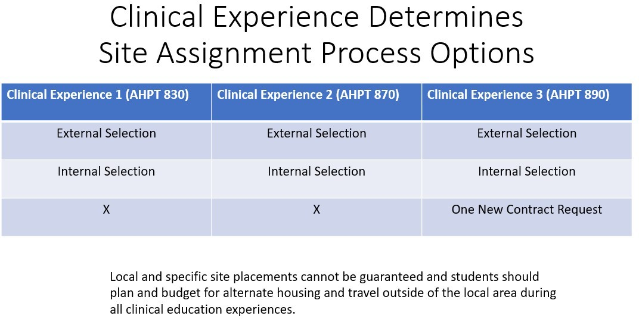

External Selection Process for AHPT 830, 870 & 890
- Some sites use an external student selection process which differs from the internal selection process.
- The timing of external selection offers varies as they are determined by our clinical partners. Typically, in the Fall semester, multiple clinical partners offer opportunities that students may apply for within the Clinical Administration D2L assignments boxes for the upcoming Summer clinical experiences.
- External selection processes include sites with a designated representative or process that directly selects students to participate in site experiences within their facilities.
  - Each site has its own selection process, e.g., online application, essay, resume, interview.
  - Once selected by a clinical partner, students are obligated and directly assigned by the DCE.
  - If an external selection partner cancels, the DCE coordinates with the student outside of the external and internal selection processes to determine and assign directly to a site that meets their academic needs.
  - Note, that some sites are accessible to 3rd year (AHPT 890) placements only: Eduglobal, Hillside, Carilion Children’s, Sheltering Arms, and Carilion Roanoke Memorial Hospital acute care.
- Students with a confirmed site assignment via external selection processes before the internal selection process does not participate in the internal selection process.

Internal Selection Process for AHPT 830 & 870
Students without a clinical site assignment at the initiation of the internal selection process are obligated to participate in the internal selection process fully or will be directly assigned to a clinical site by the DCE following the internal selection process.
  - The internal selection process begins with assigning the 2nd year students preparing for AHPT 870 first, followed by 1st year students preparing for AHPT 830.
  - Rationale for order: Many sites available for 870 are not available or appropriate for 830 due to: a) the patient population, b) the student’s level of preparation based on the curricular sequence, and c) our clinical partner’s ability/willingness/decision to host students based on their level of preparation
- The internal selection process is initiated mid-spring semester for students preparing for AHPT 870 (2nd clinical experience), registered in the subsequent summer semester as follows:
- Students are provided a list of all available clinical sites a minimum of 3 business days before assignment.
- Students rank their clinical site in order of preference from all options available and submit their list to the D2L assignment box by the due date provided. Students who do not submit their ranked list by the deadline will not participate in the internal selection process and will be directly assigned by the DCE after all other students are assigned via the internal selection process.
- Students are provided a number at random that designates the order in the selection process using the device pictured below:
- The student hands their number to the DCE or designated assistant for logging/tracking purposes.
- The DCE maintains the log and assigns students to sites in sequential order based on the student’s number and the availability of each student’s top-ranked preference.
  - For example, for a cohort of 30 students in AHPT 870, each student will be provided a number from 1 to 30 at random.
  - The student with #1 is assigned first, followed by the student with #2, #3, etc. until the 30th student is assigned.
- The full internal selection process (1 – 5) is repeated mid-spring semester for students preparing for AHPT 830 (1st clinical experience), registered in the subsequent summer semester, with the DCE providing a list of all available clinical sites a minimum of 3 business days before assignment.
- Once sites are assigned through the internal selection process, site assignments will not be changed.

Access the Third Year New Clinical Education Contract/ Site Placement Request Form and an overview of both processes in the Appendices.

SEQUENCE OF CLINICAL EXPERIENCES
The overall goal of the clinical education curriculum is to provide students the opportunity to experience diverse practice settings that build on skills mastered within the didactic aspect of the curriculum. The development of students to perform as entry-level practitioners of physical therapy before graduation is the most important factor in these assignments. The program is required by the CAPTE accrediting board to provide diverse settings representative of current practice.
Clinical experiences offer the opportunity for students to apply knowledge, skills, and professional attributes gained through previous curricular experiences. Students are required to participate in three
(3) unpaid 12-week full-time clinical experiences as part of their professional education as shown below:

Year 1: 12-week placement mid-May to early August
Year 2: 12-week placement mid-May to early August
Year 3: 12-week placement early to mid-January to mid-April

For best outcomes, based on the program’s didactic coursework as well as feedback from Site Clinical Education Coordinators, CIs, and graduates of the program, students are placed in experiences as follows:

Year 1: outpatient rehabilitation or skilled nursing
Year 2: outpatient rehabilitation, inpatient rehabilitation, skilled nursing, acute/hospital, home health, or any practice type not previously experienced (outpatient or skilled nursing facility).
Year 3: any location where physical therapists currently practice.

Notes: This program is an entry-level program
- Specialty site settings are not required
- Specialty sites typically require students to be in their third year and final experience, e.g., pediatrics, women’s health, and others to be determined.
- Selection is typically external to the DPT clinical education site selection process for these placements and may include at minimum, an application process, interview, with student selection by the site or company, not the DPT program.

Students without placements confirmed by the midterm of the preclinical semester will be assigned directly by the DCE in collaboration with the program chair. Students may decline a student clinical placement assignment, but this will delay their continuation or completion of the Physical Therapy Program.

Clinical experiences or segments of missed clinical experiences due to unforeseen circumstances will be “made up” after all other coursework is completed and only by permission of the DPT faculty. This will likely delay graduation.

ACADEMIC CALENDAR: TIMING OF CLINICAL EXPERIENCES
- Students are referred to the Radford University academic calendar for specific semester Start dates only: https://www.radford.edu/content/radfordcore/home/academics/courses-and-schedules/calendar.html
- The DPT clinical experiences are 12 weeks full-time. The calendar follows the Radford University academic calendar with summer Clinical Experience 1 & 2 beginning with the Radford University Summer III and extending two weeks beyond the 10-week summer session.
- Clinical Experience 3 begins with the RU academic spring semester and ends two weeks before the end of the semester.

UNIVERSITY ROLES, RESPONSIBILITIES & RIGHTS
The university strives to provide an educational environment conducive to student learning and development and must protect its educational purpose by setting standards of scholarship and conduct. The guiding principle of university regulations is to promote student responsibility and accountability while protecting the community. Students have the responsibility to follow all regulations outlined in this policy. Radford University likewise has the responsibility to provide a student conduct process that is: Free from discrimination and harassment based on sex, sexual orientation, race, disability, age, veteran status, national origin, religion, or political affiliation; fundamentally fair; and inclusive of the option for a hearing and an appeal, as outlined in this policy.

STUDENT ROLES, RESPONSIBILITIES & RIGHTS IN CLINICAL EDUCATION
Students are required to follow all regulations outlined in the University’s Standards of Student Conduct Handbook, the Waldron College of Health and Human Services of Professional Practice Education, the Department Student Handbook, and the Clinical Education Handbook.

PRE/CLINICAL EDUCATION REQUIREMENTS

The DPT program uses the CastleBranch tracker system to safely store programmatic and site-specific requirements, e.g., student health records, including PPD/QuantiFERON Gold and Immunizations.

In addition to programmatic requirements, some sites require additional immunizations, titers, testing, background checks, and drug screens, among other items. No requirements, e.g., CPR, may lapse while the student engages in clinical education experiences.

Once assigned, the DCE will provide site-specific requirements that need to be met during the preclinical semester, not limited to:
- CPR Certification: The American Heart Association BLS-C Health Care Provider CPR course is required. Renewal for the AHA/BLS-C certification is every two years. Radford University offers CPR courses throughout the year. It is the student’s responsibility (e.g. APTA core value of professional duty) to update CPR on a timely basis to maintain current CPR certification throughout clinical education experiences. In the circumstance of CPR lapses during a clinical experience, the student may be removed from the clinic for not meeting standards of practice as dictated by the accrediting hospital/practice agencies and the DPT Program.

- Criminal Background and Drug Screen Requirement: Radford University’s DPT program utilizes CastleBranch (https://mycb.castlebranch.com/) for all clinical education preclinical background checks, drug screens, and the health tracker system. Students are required to pay for, complete, and successfully pass a CastleBranch Background and Drug Screen each preclinical semester. If background and/or drug screen results are not received in the identified period, students will be prohibited from attending clinical experiences.
Background and drug screen results may prevent student participation in assigned clinical experiences and DPT program dismissal. Students are reminded that assigned clinical sites may require additional preclinical screenings in addition to these DPT program requirements.

In the circumstances that a student’s background or drug test is positive or flagged, the Radford University Clinical Clearance Coordinator will bring this to the attention of the DCE.

The DCE will bring this to the attention of the student. The DCE will refer to the current clinical agreement with the organization where the student is currently assigned. Based on the current clinical agreement, the DCE may be required to share this information with the assigned clinic and in that case, the assigned organization will determine whether or not to allow the student to attend clinic. If the assigned clinic refuses to accept a student based on a background or drug test, the student’s case will be reviewed by the Clinical Education Review Committee and the DPT Program Chair for the next steps. The next steps may include a delay in attending clinical education sites, the student being assigned directly to an alternative site as available, a delay in graduation, or dismissal from the program.

In Summary:
  - DPT Students will complete a drug test and background check during each preclinical semester before each clinical experience. These records are available to the program administrative assistant, program chair, and DCE via CastleBranch login and password.
  - Clinical sites may require their own background and drug testing in addition to those required by the department. Students are responsible for these additional expenses. These must be completed by the deadline indicated by the DCE to attend the clinical experience assigned.
- Malpractice insurance: All students are covered by Radford University malpractice insurance while functioning as a DPT student in course-related activities. The student is not responsible for obtaining malpractice insurance as this is covered by Radford University.
- Release of Records: The department will not release student information except as allowable per the University policy without obtaining the written consent of the student. A full statement of the Family Educational Rights and Privacy Act (FERPA) and information as to how students may exercise the rights accorded them by this policy are available from the office of the University Registrar or the Dean of Students Office. Release of Records and Information is collected and secured within the D2L preclinical/clinical courses.
Students may revise the release of information at any time by providing written notice to the DCE or the Department Program Chair. The release of records form may be accessed on the RU registrar website: https://www.radford.edu/content/dam/departments/administrative/registrar/content-files/forms/FERPA-Form.pdf

University and federal laws permit the university to routinely release information in the following categories:
  - Student’s name, local & home address, phone listing
  - Email address
  - Major field of study
  - Participation in officially recognized activities & sports
  - Weight & height of members of athletic teams
  - Photograph
  - Dates of attendance
  - Degrees & awards received
  - The Department of Physical Therapy may request students release additional records for program improvement and accreditation reporting.

  - Clinical Education Handbook: The student will sign and submit directly to DCE an Acknowledgement of Clinical Education Handbook including updated editions during orientation and each of the preclinical semesters. The most recent Clinical Education Handbook may be accessed on the department’s clinical education page and within the preclinical course platform.
  - Students are not Employees: Students participating in the clinical educational program of the physical therapy program shall not be deemed employees of the clinical site for compensation, fringe benefits, worker’s compensation, unemployment, minimum wage laws, income tax withholding, or social security.

  - Scholarships: Students may only receive monetary funding in the form of a scholarship to further their educational experience during the clinical experience(s).

Contacting Sites, Site Coordinators, and CIs
  - Student Introduction Clinical Education Letter: To assist with the best possible outcomes, students will be responsible for writing a letter of introduction to each of their assigned CI before each clinical experience which will be approved by the DCE. The DCE will email the approved letter, student’s personal development plan, resume, and first week’s goal sheet to assigned CIs.
    - Letter of introduction will include, but are not limited to:
    - Describing how the student learns best
    - Identifying personal strengths and needs, e.g., reference the Clinical Performance Instrument criteria
    - A list of desired personal experiences, goals, and outcomes from the clinical experience beyond course requirements
    - Clinical curricular outcome expectations

- Students are to contact their assigned CI as directed by the DCE, and at least 4 weeks (30 days) before the clinical experience to:
- Review clinical site requirements and CI expectations,
- Request a list of the most common diagnoses to best prepare for each experience
- Confirm logistics like dress code, where to park, lunch break on-site, and typical practice hours, etc.
- Students and CIs should also exchange contact information before the first day of the clinical experience to maintain effective communication.
- Contact information may be directly accessed once students and CIs are linked by the DCE on the CPI.
- For best outcomes, students and CIs are advised to inform the DCE if attempts to contact their assigned CI have not been successful at least 4 weeks before the start date of the clinical experience.

Clinical Experiences Attendance
  - As courses within the DPT curriculum, clinical experiences abide by attendance requirements common to all courses. Clinical experiences are 12 weeks in duration and full-time. The official RU policy states: “All students are expected to be officially registered and attend classes regularly. No absences of any nature will be construed as relieving the student from responsibility for the completion of all tasks assigned by the instructor. A student registering late for a class will be responsible for all work assigned and material covered during the class sessions missed due to late registration.”
  - Students who are not registered for a clinical education course while attending clinic risk removal from clinic and dismissal.
  - Students are expected to report to their clinical site prepared and on time. Absences other than those preapproved by both the DCE and the onsite CI will not be tolerated. Program faculty realizes that the circumstances in life may occur that we cannot control such as personal or family medical emergencies, and in these cases, you are to contact the DCE as soon as safely possible.
    - Third-year students will receive a letter from the curriculum committee chair regarding the NPTE. This letter includes the following statement: “You have 4 weeks to take the first PEAT exam. Taking time off during your clinical affiliation to study or complete the PEAT exam is NOT permissible.”
  - Students presenting with flu-like symptoms are encouraged to stay home for the safety of their patients, clinicians, and themselves. Please see the Leave and Excuse Policy below for more information regarding clinic absences.
ABSENCE POLICY (Clinical Experience Courses)

Student(s) are required to complete 3 full-time 12-week clinical experiences (or total full-time equivalent) to fulfill DPT clinical education curriculum requirements.

Policy: Full-time clinical attendance is required within each 12-week clinic experience based on the assigned clinical faculty’s work schedule. Unexcused absences or repeated tardiness will result in a grade reduction or course failure.

Full-time clinical attendance is defined based on the concept of a 40-hour work week although each clinical site defines full-time differently and the site’s definition of full-time supersedes the otherwise 40-hour rule. Therefore, any absence during a clinical education course may require make-up time scheduled at the discretion of the clinical faculty and is limited to clinical site availability.

Procedure: The student will be expected to assume the work schedule of site-assigned clinical faculty which equates to a full-time work schedule. A frequently asked student question is, “What is the expectation during holidays such as July 4th if my assigned clinician is working the holiday?” The answer is the same as every day: you follow your CI’s schedule.

Pre-planned absences related to professional development such as conferences require prior approval by the DCE and CI before the start of the clinical experience. A plan of action will be established between the CI and student to address any make-up needs to maintain the expectation of full-time clinical status. The student is to email the DCE the dates of absence(s) and the proposed “make-up” plan.

The student is responsible for notifying the DCE by email of any absence, planned or unplanned, from the clinic.

In emergent circumstances where calling or emailing is not possible, students may request the CI (or emergency contact) contact the DCE.

In the event of an unexpected or unplanned absence:
- Any emergent absences are required to be reported to the onsite assigned CI before the clinic day as feasibly possible.
- The student is responsible for notifying the supervising clinical faculty before the start of the work day.
- The student is also responsible for notifying the DCE by email within 24 hours of any absence from the clinic.
- Repeated absences or tardiness may result in grade reduction with course grade reduced by 10% for each day missed without student informing their CI, or course failure.
- Attendance in the clinic is acknowledged on weekly goal reflection worksheets and midterm/final Clinical Performance Instruments signed off by students and supervising CIs to confirm this requirement is met and is tracked by the DCE or designee.
- Medical absences or illnesses longer than or equal to three (3) successive days require written medical release/documentation before returning to clinical experiences with copies provided to both the clinical site and the DCE.
  - Repeated absences will be reviewed on an individual basis by the CI and DCE. Repeated absences or tardiness may result in grade deduction (course grade reduced by 10% for each day missed) or course failure.
  - The availability of “make-up” time will be limited due to clinical site accessibility. This will potentially result in a postponement of graduation based on curricular lock-step requirements local clinical site availability, and restricted semesters dedicated to clinical experiences.
  - If a student misses 1/3 or more of a clinical experience (time that equates to 4 full-time weeks) may result in an “Incomplete” or “In-Progress” grade and the student may need to repeat an additional 12-week clinical experience. An individualized plan will be developed to ensure that the student meets the curricular requirements.

Dress Code/Clinical Experience Attire

Clinical dress is based on the student’s assigned site’s dress code/policy. Contact your assigned CI for more information. Students are to follow the expected clinical site attire. A white, clean laboratory coat may be required and is to be purchased by the student.

In the circumstance where there is no written policy at the clinical site, students are expected to follow the DPT program clinical dress policy described within the Radford University DPT student handbook. Additionally, at all times while onsite in the clinic, students are expected to wear their Radford University DPT photo ID badge which includes the Radford University logo, Student Name, and Photograph unless the clinical site requires an alternate ID badge.

Housing & Meals
Students are responsible for providing their room and board, including the cost of housing and meals during all clinical experiences.

Travel/Transportation Policy
Students are responsible for providing their transportation to and from clinical experience sites. Adequate coverage of automobile insurance must be maintained and is the personal responsibility of the student. Students should also be aware that transporting others (e.g., clients or patients, utilizing a personal vehicle) makes them personally liable, and are hereby advised not to transport patients/clients during clinical experiences.

Surveys
Students are expected to complete surveys regarding the site, CI, and DCE for each clinical semester.

DCE, CI ROLES, RESPONSIBILITIES & RIGHTS
  - Clinical assignments and courses are arranged and assigned by the DCE.
  - Course objectives and CI expectations are mailed to the CIs at contracted sites to assist in reinforcing content currently presented in the classroom setting and for communicating outcome expectations.
  - Expectations may also be found within the clinical education course syllabi and in course materials via the online D2L platform.
  - Clinical experiences offer the opportunity for students to apply skills, knowledge, and professional attributes gained through previous curricular experiences. The goal is for the clinical aspect of the curriculum to be diverse. The development of students to perform as entry-level practitioners of physical therapy before graduation is the most important factor in these assignments.
  - To assist with the best possible outcomes, students will write a letter of introduction to each of their assigned CIs before each clinical experience. Letters of introduction will include but are not limited to describing how the student learns best, his/her self-assessed strengths and needs, and a list of desired experiences, goals, and outcomes from the clinical experience. The DCE will share the student’s letter with the assigned CI within the preclinical packet that includes at a minimum the letter of introduction, resume, development plan, and first week’s goals.

DCE Roles and Responsibilities:
  - Has oversight over the clinical education program within the DPT curriculum
  - Ensures the development of student clinicians by providing students access to opportunities to practice physical therapy clinical skills.
  - Develops, manages, coordinates, administers, analyzes, and adjusts the clinical education program to meet the current APTA vision and practice exceptions.
  - As the chair of the Clinical Education Review Committee (CERC), performs assessment activities to improve the clinical education program and contribute to comprehensive program assessment.
  - Represents Radford University and the Radford University community at large and contributes to the development of clinical education faculty as clinical teachers, mentors, and practitioners.

DCE ASSESSMENT
Multiple assessment tools are used to assess whether the DCE meets role expectations as described in the APTA Model Position Description for the PT Program ACCE/DCE: http://www.apta.org/ModelPositionDescription/ACCE/DCE/PT/
Assessments of the DCE include, but are not limited to:
  - DCE Performance Assessments for CIs and SCCEs
  - DCE Performance Assessments for Students
  - DCE Annual Performance Evaluations by the Chair

CLINICAL FACULTY ROLES AND RESPONSIBILITIES
Information about the APTA Clinical Site Information Form (CSIF and CPI 3.0) developed by the Department of Physical Therapy Education (3030 Potomac Ave., Suite 100, Alexandria, Virginia 22305-3085) may be accessed at American Physical Therapy Association online: https://www.apta.org/for-educators/assessments/pt-cpi

Once clinical sites are contracted, SCCEs will be asked to identify physical therapists who demonstrate exemplary clinical competence in areas of expertise or specialty in practice including APTA credentialed instructors (CIs) on the APTA Clinical Site Information Form (CSIF).

The program expects all clinical education faculties to demonstrate clinical teaching effectiveness in the areas of supervision, mentorship, communication, and core professional values and to meet clinical experience course objectives and outcomes.

Clinical faculty are encouraged to reach out to the program DCE with questions at rhuth@radford.edu or 540-831-1892.

CI ASSESSMENT
Multiple assessment tools are used to assess whether clinical education faculty are effective teachers. These assessment tools evaluate student supervision, mentorship, communications, and core values. Assessments go through a triangulated review by the Clinical Education Review Committee (CERC).

Data gathered from conferences, surveys, and student reflections is triangulated, and reviewed by the DCE and CERC to the full faculty at least once monthly.
  - CI reviews both students, DCE, and curriculum
  - Student reviews both the CI and DCE, assigned site, and curriculum
  - DCE reviews students, CI & DCE
  - The Clinical Curriculum Review Committee reviews the Clinical Education Program

CLINICAL FACULTY RIGHTS AND PRIVILEGES
The responsibilities of clinical faculty (SCCEs and CIs) are delineated by the DCE following clinical agreement execution and confirmation of the clinical placement availability. The DCE is responsible for coordinating, managing, and communicating the efforts of the academic program and clinical education sites in the education and preparation and follow-through of DPT-assigned student clinical experiences. Communication methodologies include emails, ongoing telephone conferences, on-site visits, department website, video conferencing, CPI Web, CERC participation, and ongoing CEU on-site training.
The clinical education faculty (SCCEs and CIs) are afforded rights and privileges appropriate and like the rights and privileges of clinical faculty in other Radford University programs. All clinical faculties at Radford University DPT have access to research resources including a library, laboratory space, department equipment, and support from the Office of Sponsored Programs and Grants Management. Additional privileges include:
  - Continuing Education Opportunities: Free CPI web training through APTA Learning Center: Clinical faculties who have not taken CPI web training will be instructed to do so. Training is required by all Radford University DPT CIs. For more information about the CPI training https://www.apta.org/for-educators/assessments/pt-cpi
  - All CIs will receive a certificate indicating their participation in the Radford University DPT clinical education program including supervision hours for Type II continuing physical therapy education credit based on the Commonwealth of Virginia policies.
  - Representatives from clinical sites who have provided clinical education for DPT students will be invited to participate in the university’s career recruitment fair.

POLICIES
Americans with Disability Act and Acknowledgement of DPT’s Policy for students with disabilities. Please refer to the Student Handbook for more information.
Attendance—See the complete Leave of Absence Policy within the Student Handbook.

Clinical Experience Grading Policies- Student Clinical Experience grades of pass/fail will be determined by the DCE. Reporting of grades will be communicated with students within the online D2L course. Please refer to the Student Handbook for more information as well as the Clinical Remediation/Dismissal Policy and Procedures within this Clinical Education Handbook.

Clinical Site Information Sharing Policy-Prior to the clinical experience, and after a release of information is signed by the student and provided to the DCE, the Department of Physical Therapy may provide the following information to CIs and or the coordinator of clinical education upon request:

  - CPR certification
  - Student contact information
  - Listing of courses completed
  - Certification of HIPAA and Standard Precautions training
  - Drug test results
  - Background check information-Criminal background check information may be released to the clinical sites by request. The Department of Physical Therapy will notify clinical sites that the student has completed a current criminal background check and that the program has determined that the student is suitable for clinical practice.
Students are encouraged to disclose further personal information to their assigned CIs albeit academic or disabilities within their introduction letter for the best possible outcome success of each clinical experience. The letter of introduction is sent to the CI and a copy is maintained within the student clinical education record.

Clinical Education Calendar
Spring clinical experiences begin with the regularly scheduled semester and following the 12-week clinical, students return to the department to finalize academic requirements including their capstone projects. The summer clinical experience start date aligns with summer session III. However, to allow for 12-week experiences during the summer semester, the clinical experiences extend two weeks beyond the 10-week summer session III.

Clinical Remediation/Dismissal Policy and Procedures
Students are required to complete and pass three full-time clinical experiences (or what equates to 36 full-time clinical weeks). Clinical experiences are intended to expose students to a variety of experiences and entry-level professional skills. Grading for clinical experiences is based on a pass/fail system. The pass/fail system is based on a point system which equates to the “Rubric Grading Scale” per the Student Handbook. A score of “B” or better defines a passing grade. Final course grades are recorded by the DCE of Radford University’s Physical Therapy Program.

The DCE, in collaboration with the Program Chair and CERC, determines that the student has “Failed” the clinical experience.

A student with a failed clinical experience will be dismissed from the program.

An automatic course failure will occur in the following situations:
  - The student contacts a site directly to request a new contract or site placement.
  - The preclinical requirements of the clinical placement site are not met before or during the clinical experience. Examples include positive drug tests, flagged background checks that do not meet clinical site requirements, and other clinical site-specific requirements requested by the assigned clinic.
  - Scores tallied within the clinical education course equates to below a “B” as described within the Student Handbook.
  - The SMART plan is not completed in the defined period or does not meet the objective set forth and agreed upon by the student and DCE. Examples include documented repeated unprofessional behavior(s) and/or safety offenses.
  - Does not complete what equates to 36 full-time clinical weeks of clinical education as defined by the Attendance Policy within the Student Handbook.
A grade of “In Progress” (IP) or “Incomplete” (I) may result when the DCE determines that the student has not met the academic or professional criteria of the course. The DCE will request a review by the Program Chair and/or CERC Committee before final grades are granted.

Examples in which this may occur include, but are not limited to:
  - Medical leave
  - Leave of absence
  - Military deployment
  - Where the site cannot make reasonable accommodations for the needs of a student

The student granted an “IP” or “I” will not graduate in the normal sequence schedule due to the program’s lock-step curriculum.
A student provided a grade of IP or I require a SMART plan. Development and implementation of this SMART plan will include the student, DCE, and other assigned faculty, such as the Program Chair, CERC members, and the student’s academic advisor. The purpose of the SMART plan is to remediate student deficits noted during the clinical experience. The student will propose the SMART plan under the direction of the DCE. The student must obtain signatures of approval from all parties named in the plan (i.e. student, faculty, advisor, DCE). The student must abide by the timeline established for each component of the SMART plan. Once the SMART plan has been completed and objectives are met, the student may resume continuance in the clinical experience sequence. If the student does not complete the SMART plan, the student will be dismissed from the program.

Communications Technology Policy
Students participating in clinical experiences may use personal cell phones only during scheduled lunch breaks or during regularly scheduled daily breaks. The use of cell phones including texting is prohibited during all clinical treatment times and learning experiences e.g., patient treatments, seminars, professional presentations, and clinical instruction. CIs have the authority to uphold this policy including requesting that cellphones be put away and not brought into clinical sites. CIs who observe students violating this policy are encouraged to discuss this with students in a direct and timely manner and to then document the discussion. If students are observed repeating this offense after this discussion, CIs are asked to follow up with the DCE who will then further discuss this with the student. A potential consequence is that the student may be dismissed from the clinical education experience.

Interruption of Clinical Experience – See Clinical Remediation/Dismissal Policy and Procedures There are various reasons why a clinical experience may be interrupted, not limited to absences due to illness, medical, maternity leave, military leave, and student performance (e.g., repeated safety issues). The determination to drop or withdraw a student from a clinical experience course will be made by the DCE in collaboration with the student, CI, the program chair, and designated faculty.
Remediation plans will be determined on an individual basis by designated faculty overseen by the DCE.

Student/CI Planning and Feedback
Students are required to develop proposed weekly goals that reflect affective, cognitive and
psychomotor emphasis reflective of the CPI criteria. The CI and the student will review the student's proposed goals at the beginning and end of each week during the clinical experience. CIs and students may agree to have the student document CI verbal feedback received throughout the week on the goal sheets to facilitate effective and timely discussions. Goals will be due by the end of each week via D2L, with the exceptions of the midterm week and the final week.

Clinical faculty, students, and the DCE will use the Liaison International system software CPI as the main form of communication tool at midterm and final. Each student and CI will be required to take the free CPI online web training course to become familiar with and obtain access to the management system before the student attends the clinic. Student clinical performance will be graded on the CPI criteria per the APTA guidelines.

Accessing the CPI
Information on how to access the CPI for midterm and final will be posted via D2L during the clinical experience.

Weekly Goals Sheets
All student weekly goals and reflections as well as the CPI midterm and final are to include comments of support that include all five Performance Dimensions as described within the CPI training and guide:
- Supervision & Guidance: refers to the level and extent of assistance required by the student to achieve entry-level performance. As a student progresses through clinical education experiences, the degree of supervision/guidance needed is expected to progress from 100% supervision to being capable of independent performance with consultation and may vary with the complexity of the patient or environment.
- Quality: refers to the degree of knowledge and skill proficiency demonstrated. As a student progresses through clinical education experiences, quality should range from a demonstration of limited skill to a skilled or highly skilled performance.
- Complexity: refers to the number of elements that must be considered relative to the patient task, and/or environment. As a student progresses through clinical education experiences, the level of complexity of tasks, patient management, and the environment should increase, with fewer elements being controlled by the CI.
- Consistency: refers to the frequency of occurrences of desired behaviors related to the performance criterion. As a student progresses through clinical education experiences, consistency of quality performance is expected to progress from infrequently to routinely.
- Efficiency: refers to the ability to perform in a cost-effective and timely manner. As the student progresses through clinical education experiences, efficiency should progress from a high expenditure of time and effort to economical and timely performance.
Overall grades are determined and posted by the DCE based on the course syllabi grading criteria, student feedback, and CI feedback. On-site visits and/or teleconferences will be conducted whenever possible or by request of the student and/or CI.

Student Clinical Experience Policy
The program faculty has determined the types and progression of student clinical site placement based on the curriculum.
  - Students participating in their first clinical experience placement will have the opportunity to gain clinical experience in skilled nursing home facilities and outpatient clinical environments.
  - Once students complete their second year of the curriculum and again based on curriculum content, clinical experiences, and clinical skills development their clinical opportunities will be increased from sites identified in year 1 to include acute care and homecare environments.
  - Students participating in their third and final clinical experience will have completed all of the course sequences in the doctoral curriculum and are eligible to participate in all clinical practice environments previously identified as well as specialty areas such as pediatrics, sports medicine, industrial rehab, women’s health, and school programs.

Student Grade Determination
Overall grades will be determined and posted by the DCE of the Physical Therapy Program based on the course syllabi grading criteria, conference, CI’s grading, and feedback on the CPI, as well as student feedback.

Processing Complaints
Concerns from students, CIs, and clinical partners about any aspect of the clinical education program or its constituents are encouraged to be communicated directly and promptly to the DCE. “Timely manner” is defined as during the clinical experience or no later than 14 days after the final day of the assigned clinical educational experience.

All concerns regarding student safety or clients/patients MUST be directed promptly to the DCE and flagged on the CPI. Students may be pulled immediately from treating patients until the DCE is contacted. Whenever safety is in question, all practitioners are reminded to “do no harm.”
  - Complaints regarding the Clinical Education Program may be made to: Dr. Renée Huth, DCE, (540) 831-1892 or rhuth@radford.edu
  - Complaints regarding the DCE may be made to the Program Chair with contact information located here: https://www.radford.edu/content/grad/home/academics/graduate-programs/pt.html
  - Complaints regarding the Program Chair may be made to the Associate Dean of Waldron College with contact information located here: https://www.radford.edu/content/wchs/home.html
For more information regarding the grievance or complaints process, please review the Department of Physical Therapy Student Handbook which may be accessed on the department’s website, or contact the DCE (rhuth@radford.edu).

Clinical Education Outcomes Evaluation
While the DCE oversees and directs the Clinical Education aspect of the curriculum, the core faculty, including the DCE, is responsible for the development, implementation, review, and continued improvement of the professional curriculum which includes the Clinical Education Program.
Curricular content and its ability to prepare students to meet clinical demands are assessed continuously.

Methods used in the assessment process will consist of regularly scheduled faculty meetings, annual faculty retreats, input from student focus groups, and triangulation of data gathered from multiple surveys, student reflections, the CPI, conferences with CIs, and on-site visitations by the DCE. Input from the clinical community is welcome informally and formally at CERC meetings.

Additional feedback used to assist in the evaluation and continuous improvement of the clinical education program includes:

- CPI Web assessments: DCE, CI, and student
- Student self-evaluation
- Surveys of Site, CI, DCE, and curriculum
- Evaluation of curriculum
- DCE onsite, Zoom, and telephone conferences with students and CIs
- Director of Clinical Education annual evaluation by the Chair
- DPT Program Committees: Clinical Education Review and Curriculum Committee
- DCE participation in Mid-Atlantic Physical Therapy Clinical Education Consortium

Appendices

AHPT 890/Third Year New Clinical Education Contract/ Site Placement Request Form
Please copy and paste this form to a Word document, fill it in, and upload it to the appropriate course platform as instructed by the DCE. Save the document with the following naming system and submit the request form to the appropriate D2L assignment box as instructed by the DCE no later than the last day of the second curricular fall semester: Last name; Cohort Year, 3rd clinical new agreement request, e.g., Miller_2025_3rd_new site

When a student has identified a possible uncontracted clinical education site, the student must submit the request following directions provided by the DCE at least 13 months before the start date of the third clinical experience to begin the placement request process. This is typically by the end of the second-year fall semester.

At no time is the student to contact the site directly to request a new contract or site placement.

Student’s name Date of request
Site Type: Site Name: Site Address: Site telephone number: ( ) Contact name (if available): Email (if available): Comments:

Read and check the following boxes:
- I understand the program reserves the right to place me at specific sites that meet my curricular requirements.
- I acknowledge that my clinical experiences are required to be diverse and allow me access to patients with neurological and orthopedic diagnoses across the lifespan and continuum of care.
- I understand that if my new site request comes to fruition, I am obligated to accept and attend.

Student Electronic Signature Date

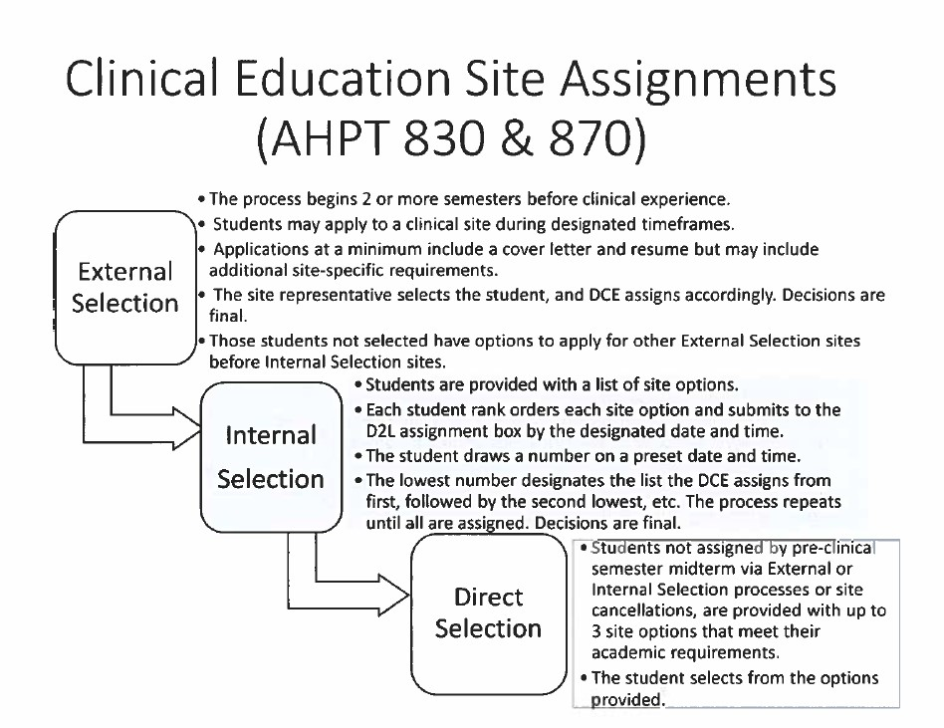

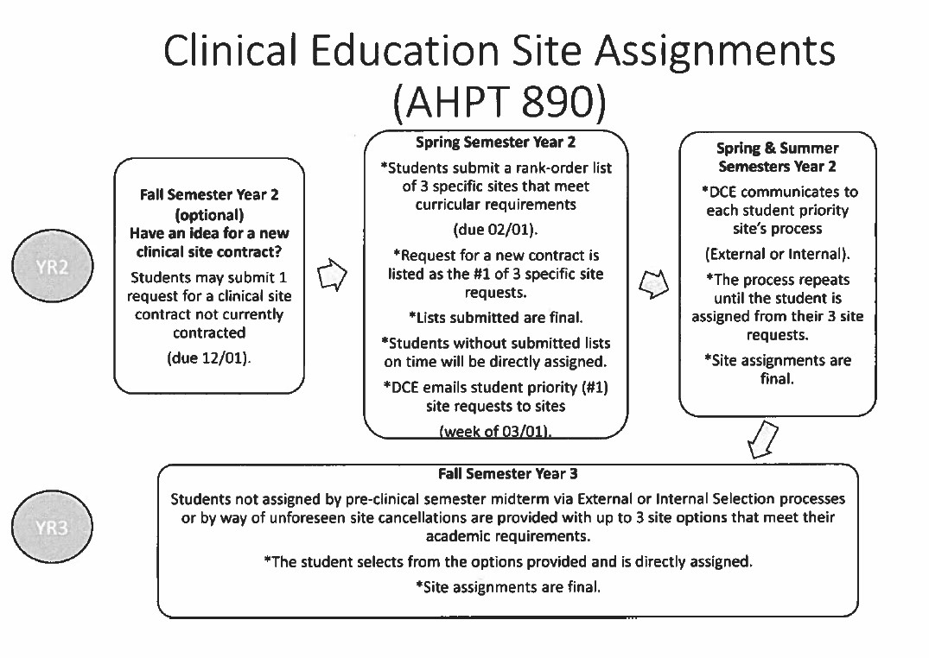
CLINICAL EDUCATION STUDENT PLACEMENT AFFILIATION AGREEMENTS

Radford University and Radford University Carilion, as an institution within the Commonwealth of Virginia, establish clinical agreements with each clinical site facilitated by the Physical Therapy Department DCE. All agreements are at minimum reviewed and signed off by the Provost’s Office, Program Director, the Dean of the College, and Radford University’s Material Management and Contracts Office. Radford University’s agreement process as of 12/2023 may be found here: https://www.radford.edu/content/procurement/home/AcademicAgreements.html

FERPA Form
https://www.radford.edu/content/dam/departments/administrative/registrar/content-files/forms/FERPA-Form.pdf
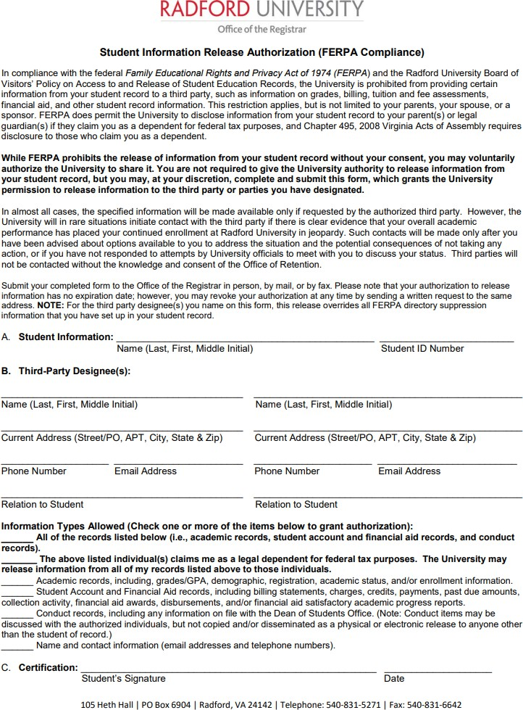

CLINICAL EDUCATION HANDBOOK ACKNOWLEDGEMENT SIGN-OFF

- I have read and have been provided an opportunity to ask questions about the materials within this handbook.
- I comprehend and acknowledge the materials presented in this Clinical Education Handbook.

Name (Student) Signature Date

Name (Student) Signature Date

This page is to be uploaded to the appropriate D2L course platforms during pre-clinical semesters for AHPT 830, 870, and 890 courses.

